Statistical Inference with JASP

The **purpose** of this activity is to give you experience using the statistical software, JASP. Using this software, you will perform inference for a mean and interpret the output.

Download JASP

* Open a web browser and go to <https://jasp-stats.org/download/>

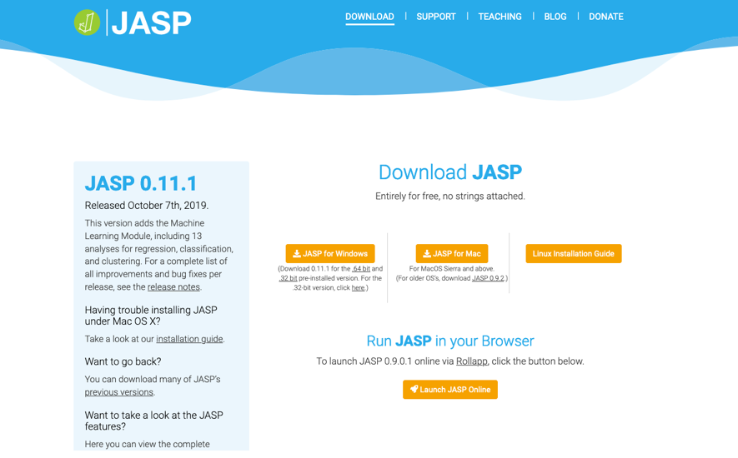

* Click either **JASP for Windows** or **JASP for Mac** depending on your computer.
  + For *Windows*, double-click the downloaded file to launch the Installation Wizard.
  + For *Mac*, double-click the downloaded file and drag the JASP icon into the Applications folder.

Starting JASP

* Start JASP. It will look like the screen shot below.

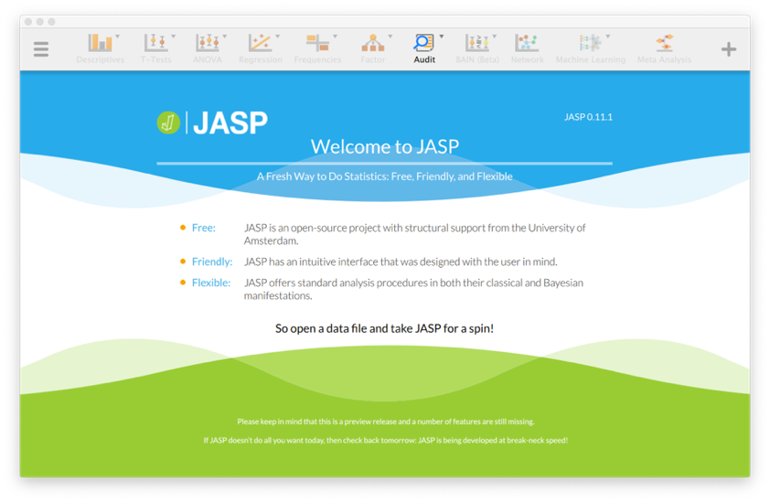

For this activity, we’ll use the *AirBNB.csv* dataset, which contains a random sample of 1,424 AirBNB entire homes/apartment listings in New York City from 2008 - 2014[1].

To load this dataset in JASP, you need

1. Click the **Hamburger Icon** () in the upper-left corner of JASP.
2. Click **Open**then **Computer**then *Browse* and find the *AirBNB.csv* on your computer (likely in your Downloads folder).

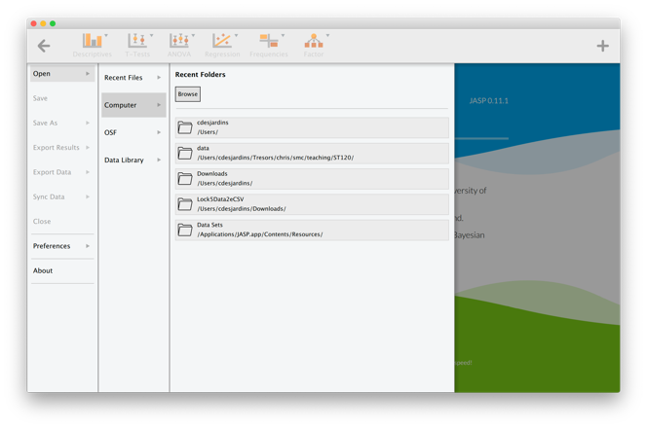

The variable name and descriptions are shown below.

|  |  |
| --- | --- |
| **Variable Name** | **Description of Variable** |
| Host.ID | Unique Host Identifier |
| Host.Since | Date began hosting on AirBNB |
| Name | Name of AirBNB listing |
| Neighborhood | Neighborhood in New York City – Bronx, Brooklyn, Manhattan, Queens, Staten Island |
| Property.Type | Type of property – Apartment, Bed & Breakfast, Boat, etc |
| Zipcode | Zipcode |
| Beds | Number of bedrooms |
| Number.of.Reviews | The number of reviews |
| Price | The cost to rent the property |
| Review.Scores.Rating | The average review scores rating |

***Research Question:*** *Is there a difference in average price between renting an entire home/apartment in NYC on AirBNB and renting a hotel room in NYC?*

To answer this research question, we will perform a t-test. Before performing the test, we will examine the **Price** variable using numerical and graphical summaries.

* Click **Descriptives** then **Descriptive Statistics**.
* Click **Price** then the upper triangle to move **Price** to the *Variables* list.
* Click **Plots, Distribution plots**



1. What is the mean (*center*) and standard deviation (*variability*) of the price of an entire apartment/home in NYC on AirBNB?
2. Describe the shape of the distribution of the price.
3. Is it appropriate to use a t-test? Explain.

The average price to rent a hotel room in NYC in 2015 was $263.45.

1. Write a H0 and a Ha that would allow us to test whether the average price to rent an entire home/apartment on AirBNB was different than the average price of a hotel room in NYC.

Perform the t-test.

* Click **T-Tests, One Sample T-Test**
* Click **Price** then the upper triangle to move **Price** to the *Variables* list
* Under *Test value:*set this to the H0 value you wrote in Question 4.
* Set the *Alt. Hypothesis* based on your Ha in Question 4.

1. What is the value of the t-statistic?
2. What is the *df*?
3. What is the value of the p-value?
4. Interpret the p-value in the context.
5. What kind of evidence do you have in favor of Ha?

Finally, you will calculate a 95% confidence interval for the average price of all entire homes/apartments listings on AirBNB in NYC.

* Set the *Test value:* to 0.
* Under Additional Statistics, select **Location Parameter** and **Confidence Interval.** This will give you the sample mean (*Mean Difference*) and a 95% confidence interval.

1. Report and interpret your 95% confidence interval.
2. Provide an answer to your research question.

1. This data was compiled from [Inside Airbnb](http://insideairbnb.com/get-the-data.html) and is modified from the data available at <https://public.tableau.com/s/resources?qt-overview_resources=1#qt-overview_resources>